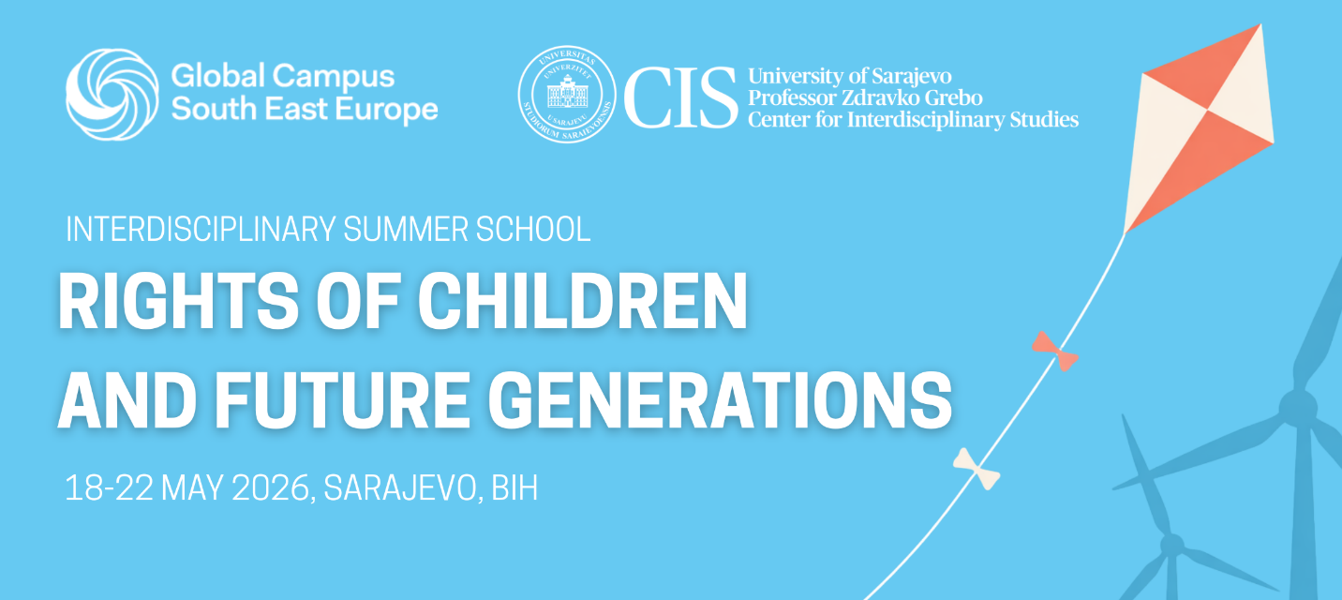
Call for Applications: Interdisciplinary Summer School “Rights of Children and Future Generations” (18–22 May 2026)
Professor Zdravko Grebo Center for Interdisciplinary Studies (CIS), University of Sarajevo, has opened the call for applications for the Interdisciplinary Summer School “Rights of Children and Future Generations,” which will take place in Sarajevo from 18 to 22 May 2026.
The programme is intended for students (MA, BA 3-4 year) and early-career professionals interested in contemporary issues related to the protection of children’s rights and the rights of future generations. Participants will have the opportunity to engage with international scholars and practitioners in the fields of human rights, children’s rights, environmental protection, social work, and public policy through lectures, discussions, interactive sessions, and visits.
The summer school aims to encourage interdisciplinary dialogue and strengthen participants’ understanding of rights-based approaches to current global challenges related to children and intergenerational justice such as poverty and violence, climate change, and protection of children in the digital environment.
The application deadline is 13 April 2026.
More information about the programme, eligibility criteria, and the application procedure is available at:
https://cis.unsa.ba/en/interdisciplinary-summer-school-rights-of-children-and-future-generations/

Otvoren poziv za prijave na interdisciplinarnu ljetnu školu „Prava djece i budućih generacija“ (18–22. maj 2026.)
Centar za interdisciplinarne studije prof. dr. Zdravko Grebo Univerziteta u Sarajevu (CIS), objavio je poziv za prijave na interdisciplinarnu ljetnu školu „Prava djece i budućih generacija“, koja će se održati u Sarajevu od 18. do 22. maja 2026. godine.
Program je namijenjen studentima i studenticama (MA, BA 3-4 godina) te mladim profesionalcima zainteresiranim za savremena pitanja zaštite prava djece i prava budućih generacija. Učesnici i učesnice će imati priliku da kroz predavanja, diskusije i interaktivne sesije sarađuju sa međunarodnim profesorima i stručnjacima iz oblasti ljudskih prava, prava djeteta, zaštite okoliša, socijalnog rada i javnih politika.
Ljetna škola ima za cilj potaknuti interdisciplinarni dijalog i unaprijediti razumijevanje pristupa zasnovanih na ljudskim pravima u suočavanju sa savremenim globalnim izazovima zaštite prava djece i međugeneracijske pravde, uključujući, siromaštvo, nasilje, klimatske promjene, kao i zaštitu djece u digitalnom okruženju.
Rok za prijavu je 13. april 2026. godine.
Više informacija o programu, uslovima prijave i načinu apliciranja dostupno je na:
https://cis.unsa.ba/en/interdisciplinary-summer-school-rights-of-children-and-future-generations/

